Literature

Hypervoicing
What is hypervoicing?
Mixtec permits only open syllables.
2 environments: initial and medial
Which group does SMD Mixtec belong to?
What is saliency?

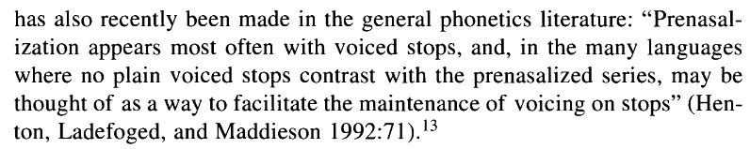
So….prenazalisation as a form of hypervoicing?

Phonetic structure in Yoloxóchitl Mixtec consonants
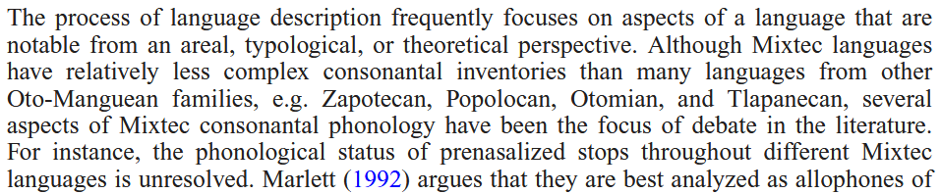
Two different approaches of analyzation

